WEEK 4 TASK REPORT
Designing Interactive Power BI Dashboards
for Construction Analytics
Virtual Construction Business Intelligence | Dashboard Design Blueprint

Task | Week 4 – Interactive Dashboard Design
Tool | Microsoft Power BI Desktop / Power BI Service
Domain | Virtual Construction & Project Management
Deliverables | Design documentation, storyboard, interaction plan, implementation guidance

Note: All figures shown in the mock-up are illustrative examples only. Replace them with verified project data before operational use.

1. Executive Summary
This report presents a design blueprint for an interactive Power BI dashboard tailored to a virtual construction business. The dashboard is intended to bring project schedule, budget, progress, labour, equipment, materials, risk and site information into a single decision-support environment. Instead of reviewing multiple spreadsheets and disconnected reports, managers can monitor key performance indicators (KPIs), identify projects that require intervention, compare planned and actual performance, and drill into the underlying details. The design uses summary KPI cards, trend charts, resource allocation visuals, status indicators, a project register and a geographic map where location data is available. Slicers, drill-through pages, tooltips and cross-filtering support exploration without overwhelming users. The design is conceptual: sample values in the storyboard are placeholders, not real company results.

2. Objectives and Business Requirements
- Provide a consolidated view of project health across active construction projects.
- Compare planned progress with actual progress to expose schedule slippage early.
- Monitor budget consumption, forecast cost and cost variance to support financial control.
- Understand labour, equipment and material allocation and spot under- or over-utilisation.
- Help project managers identify delayed, over-budget or high-risk projects and assign follow-up actions.
- Allow leadership to move from portfolio-level summaries to project-, phase- and task-level details.
- Present information clearly for business users who may not be technical data analysts.

3. Target Users and Decisions
User group | Primary questions | Decisions supported
Executive / portfolio lead | Which projects are on track? Where is exposure increasing? | Prioritise intervention, approve escalation, reallocate funding.
Project manager | Which activities are late and what is causing the variance? | Revise schedule, assign owners, coordinate dependencies.
Cost controller | Is actual or forecast cost exceeding the approved budget? | Investigate cost drivers, update forecasts, control commitments.
Resource manager | Are labour, equipment and materials available where needed? | Move resources, plan procurement, resolve bottlenecks.
Site / operations lead | What tasks are blocked, overdue or awaiting inspection? | Resolve workflow issues and update task status.

4. KPI Framework and Definitions
The KPI layer should use consistent definitions across every page. Confirm definitions with project controls and finance before deployment.
KPI | Definition / suggested calculation | Why it matters
Active Projects | Count of distinct projects whose status is Active. | Shows current portfolio workload.
Completion % | Completed work units ÷ total planned work units × 100; use weighted progress where appropriate. | Tracks delivery progress.
Schedule Variance (days) | Actual/forecast finish date minus baseline finish date; agree sign convention. | Highlights schedule slippage.
Budget Utilization % | Actual cost to date ÷ approved budget × 100. | Shows budget consumed.
Cost Variance | Earned value (EV) − actual cost (AC), if earned-value data is maintained. | Positive/negative values indicate cost performance under the chosen convention.
Schedule Performance Index (SPI) | EV ÷ planned value (PV), where EV/PV are available. | Below 1 generally indicates behind-plan performance.
Cost Performance Index (CPI) | EV ÷ AC, where EV/AC are available. | Below 1 generally indicates cost inefficiency.
Resource Utilization % | Used resource hours ÷ available resource hours × 100. | Identifies capacity pressure or underuse.
Delayed Projects | Count of projects with forecast finish later than baseline finish, using an agreed tolerance. | Surfaces projects requiring action.
Open Risks / Blockers | Count of unresolved risk or issue records by severity/status. | Supports proactive risk management.

Important: Do not compare percentages that use different weighting methods. For example, project completion should normally be weighted by work packages, quantities, or earned value rather than simply averaging task percentages.

5. Dashboard Storyboard / Mock-up
The following storyboard illustrates a possible single-page portfolio dashboard. It is a design reference, not a live Power BI report.
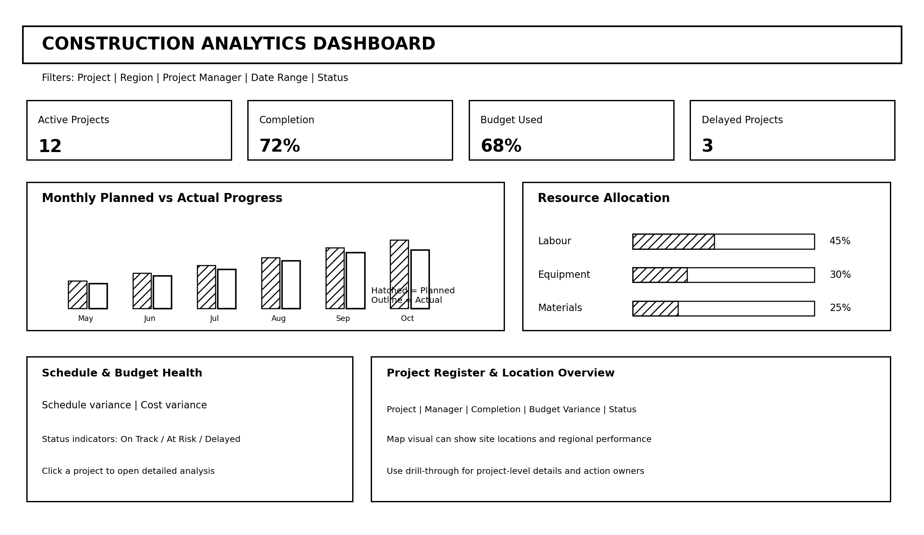
Figure 1. Construction Analytics Dashboard mock-up (illustrative layout and sample values).

5.1 Page layout zones
Zone | Visual elements | Purpose
Header and filters | Dashboard title; project, region, manager, status and date slicers. | Set the scope of analysis and make the current filter context clear.
KPI strip | Active projects, completion, budget used, delayed projects. | Give users an at-a-glance summary of portfolio health.
Progress trend | Clustered column or line chart comparing planned and actual progress by month. | Reveal whether delivery is converging with or diverging from the baseline.
Resource allocation | Bar chart or stacked bar by labour, equipment and materials; optional gauge for utilisation. | Show capacity distribution and potential bottlenecks.
Schedule and budget health | Variance cards, conditional-format indicators, or scatter plot of schedule variance vs cost variance. | Highlight projects needing attention across two dimensions.
Project register | Table with project, manager, completion, budget variance, forecast finish and status. | Provide a sortable action list and entry point to project detail.
Location overview | Map of project sites where valid geographic fields are available. | Compare regional workload, progress or risk.

5.2 Recommended report pages
Page | Core visuals | Audience / use
1. Portfolio Overview | KPI cards, planned vs actual trend, status breakdown, project register, optional map. | Leadership and portfolio reviews.
2. Project Performance | Milestone timeline, task completion, baseline vs forecast finish, issue list. | Project managers and site leads.
3. Budget & Cost | Budget vs actual vs forecast, cost variance by work package, monthly cost trend. | Finance and cost controllers.
4. Resource Management | Labour and equipment utilisation, allocation by project, material availability / shortages. | Resource and procurement teams.
5. Risks & Workflow | Open risks by severity, overdue tasks, blocked approvals, responsible owner and age. | Operations and risk review.

6. Visual Component Specifications
Component | Design and fields | Expected behaviour
KPI cards | One large number, concise label, comparison to target or prior period where available. | Respond to slicers; use clear units and avoid unexplained abbreviations.
Line chart | Month on axis; planned progress and actual progress as separate series. | Selecting a period filters compatible visuals; tooltip shows exact values and variance.
Clustered bar/column | Project or work package on axis; cost, delay days or progress as value. | Sort by largest variance to make exceptions easy to find.
Gauge / bullet chart | Utilisation or completion against a defined target and maximum. | Use sparingly; show target explicitly and avoid implying precision unsupported by data.
Stacked bar | Resource type or status split by project/region. | Compare composition and reveal imbalances.
Matrix / table | Project, phase, owner, baseline finish, forecast finish, budget, actual cost, status. | Conditional formatting flags outliers; drill-through opens project details.
Map | Latitude/longitude or validated site location with size/colour representing a measure. | Selecting a site filters related records; provide a table alternative for accessibility.
Tooltip page | Short explanation, KPI value, variance and last refresh date. | Adds context without forcing users to navigate away.

7. Interactivity Plan
Interactive feature | Implementation approach | User benefit / control
Slicers | Project, region, project manager, status and date range; use dropdowns for long lists. | Focuses analysis on the relevant portfolio slice.
Date range slider | Use a date field from a dedicated Calendar table; configure the slicer as Between where appropriate. | Allows analysis of a selected reporting period.
Drill-down | Use a hierarchy such as Year → Quarter → Month or Project → Phase → Task. | Moves from summary to detail while preserving context.
Drill-through | Create a Project Detail page and pass Project ID/name as the drill-through field. | Opens a focused detail view for the selected project.
Cross-filtering | Configure visual interactions deliberately using Edit interactions. | Selecting a chart segment updates related visuals where useful.
Report-page tooltips | Create a tooltip page with status, variance, owner and refresh timestamp. | Adds explanatory detail while keeping the overview uncluttered.
Bookmarks / navigation | Add page-navigation buttons and optional bookmarks for Portfolio, Cost and Resources views. | Improves navigation for occasional users.
Reset filters | Add a clearly labelled reset bookmark or instruct users to clear slicers. | Prevents users from misreading results left in a narrow filter state.
Conditional formatting | Use consistent rules for On Track, At Risk and Delayed based on approved thresholds. | Draws attention to exceptions without relying on colour alone.

Interaction governance: Test that slicers filter the intended visuals, that drill-through fields pass correctly, and that totals remain consistent when users change filter combinations. Avoid interactions that create confusing or circular interpretations.

8. Suggested Data Model
A star-schema model is recommended for maintainability and reliable DAX calculations. Separate descriptive dimensions from measurable fact tables.
- DimProject: ProjectID, project name, region, manager, start date, baseline finish date, approved budget, current status.
- DimDate: Date, year, quarter, month number, month name; mark it as the date table in Power BI.
- DimResource: ResourceID, resource type, role, equipment category or supplier category as appropriate.
- DimWorkPackage: WorkPackageID, project ID, phase, task category, planned weight and responsible owner.
- FactProgress: Date, ProjectID, WorkPackageID, planned quantity, completed quantity, progress percentage.
- FactCost: Date, ProjectID, WorkPackageID, budget amount, committed cost, actual cost and forecast cost.
- FactResourceUsage: Date, ProjectID, ResourceID, used hours, available hours and allocation quantity.
- FactIssueRisk: IssueID, ProjectID, severity, status, owner, opened date, due date and closed date.
Use one-to-many relationships from dimensions to facts wherever practical. Avoid unnecessary many-to-many relationships, ambiguous filter paths and mixing incompatible levels of detail in one fact table. Define currency, time zone, units and reporting cadence consistently.

9. Example DAX Measures
These are starter examples. Adjust table and column names to match the final model and confirm how blank values and project weighting should be handled.

Total Actual Cost
Total Actual Cost = SUM(FactCost[ActualCost])

Approved Budget
Approved Budget = SUM(DimProject[ApprovedBudget])

Budget Utilization %
Budget Utilization % = DIVIDE([Total Actual Cost], [Approved Budget])

Completed Quantity
Completed Quantity = SUM(FactProgress[CompletedQuantity])

Planned Quantity
Planned Quantity = SUM(FactProgress[PlannedQuantity])

Progress % (quantity-weighted)
Progress % = DIVIDE([Completed Quantity], [Planned Quantity])

Open Issues
Open Issues = CALCULATE(COUNTROWS(FactIssueRisk), FactIssueRisk[Status] <> "Closed")
For project counts and delayed-project counts, use distinct project identifiers and a documented rule for delay status. If budget is stored once per project in a dimension table, validate totals under project filters to avoid double-counting when dimensions are joined to transaction-level facts.

10. How the Dashboard Supports Construction Business Needs

10.1 Workflow efficiency
A shared view of milestones, overdue tasks, blocked approvals and issue owners reduces time spent collecting updates from separate spreadsheets. The project register becomes a prioritised follow-up list. Drill-through lets a manager open the relevant project context directly, while tooltip details help answer routine questions without creating a separate report. The dashboard should complement, not replace, the formal project schedule and issue-management process.

10.2 Resource management
Resource visuals compare labour and equipment demand with available capacity and show where materials or specialist roles are concentrated. Managers can filter by project, region or time period to explore whether a shortage is local or portfolio-wide. This supports earlier coordination of procurement, equipment transfers and staffing. Resource utilisation must be interpreted with planned maintenance, leave, shift patterns and site-specific constraints in mind.

10.3 Project performance and financial control
Planned-versus-actual progress trends, forecast completion dates, cost variance and budget utilisation help managers recognise adverse trends early. A project that is behind schedule and above forecast cost can be prioritised for review. The dashboard should display baseline and forecast definitions clearly, identify the data refresh date, and let users inspect the work packages contributing to a variance before deciding on corrective action.

10.4 Decision-making and accountability
Each exception should ideally have a named owner, next action and due date in the underlying operational system. The dashboard communicates where attention is needed; accountability still depends on agreed review meetings and action tracking. Consistent KPI definitions help leadership compare projects fairly and reduce disputes about how performance is calculated.

11. Implementation Roadmap
- Confirm users, business questions, KPI definitions, target thresholds and reporting cadence with stakeholders.
- Inventory data sources such as schedules, cost ledgers, resource logs, issue trackers and project/site registers.
- Profile data quality: missing project IDs, duplicate records, inconsistent units, invalid dates and stale updates.
- Build a star-schema model and a dedicated Calendar table; define and validate relationships.
- Create base measures first, then derived KPIs; compare totals with trusted source reports.
- Build the Portfolio Overview page before adding focused pages for project, cost, resources and risk.
- Add slicers, drill-through, tooltips, navigation and conditional formatting; test every interaction.
- Review the design with a small user group and refine labels, accessibility and performance.
- Publish to Power BI Service using appropriate workspace permissions, refresh credentials and a documented refresh schedule.
- Monitor adoption and gather feedback; maintain a change log for definitions and model changes.

12. Validation, Accessibility and Governance
- Reconcile cost, budget and progress totals against approved source reports before release.
- Test common filter combinations, drill-through behaviour, date boundaries and blank/missing data.
- Show units, reporting period, refresh timestamp and definitions for key metrics.
- Use readable fonts, meaningful titles, sufficient contrast and descriptive alt text where supported.
- Do not communicate status by colour alone; include labels or icons and provide a table alternative to maps.
- Apply row-level security if different users are allowed to see only assigned projects or regions.
- Restrict access to sensitive commercial, contractor and employee information.
- Document refresh failures, data ownership, KPI definitions and the process for correcting source data.

13. Assumptions and Limitations
The storyboard uses fictional example values to demonstrate layout only. It does not claim that any real organisation has 12 active projects, 72% completion, 68% budget utilisation or three delayed projects. Actual metrics depend on available data, agreed calculation rules and refresh timing. A geographic map requires reliable location fields and should not be included if the source data is incomplete. Advanced earned-value indicators require planned value, earned value and actual cost data at compatible levels of detail.

14. Conclusion
This blueprint proposes a practical Power BI dashboard system for construction analytics, combining portfolio-level visibility with drillable project detail. KPI cards provide a quick health check; progress and cost visuals show trends; resource views support allocation; and project registers, maps and risk views guide follow-up. Slicers, drill-down, drill-through and tooltips make the report interactive while preserving a clear information hierarchy. A successful implementation depends on consistent KPI definitions, a well-designed data model, validated source data, accessible visual design and clear ownership of corrective actions. The next step is to map this blueprint to real project data and validate the measures with business stakeholders.

Appendix A. Suggested Submission Checklist
☐ Dashboard design document completed and proofread
☐ Storyboard/mock-up included and clearly labelled as illustrative
☐ KPI names, definitions and units documented
☐ Interactive features and expected behaviours specified
☐ Data model and sample DAX measures included
☐ Workflow, resource and performance benefits explained
☐ Sample figures distinguished from real project data
☐ Final report reviewed for formatting and consistency

